Elsie McCabe Thompson
President
e: elsie@missionsociety.org p: 212.674.3500 x202 c: 212.674.3500
missionsociety.org
est. 1812

Email-Signature Instructions for Outlook
- Select the table and copy it – this is in case you need to revert to the original table.
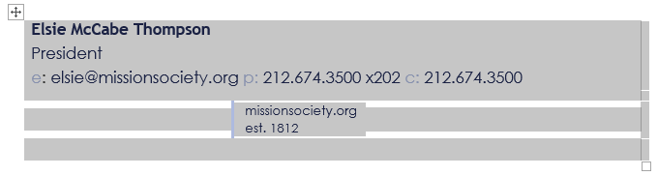
- Replace content with personal information. Ensure email is linked to to the correct email (right click the email, then select edit hyperlink). It should look like this:

- Save the file with both the original and your personalized signature. Copy the personalized table like in step 1. Open outlook and select ‘Settings,’ then click on ‘View all Outlook settings.’

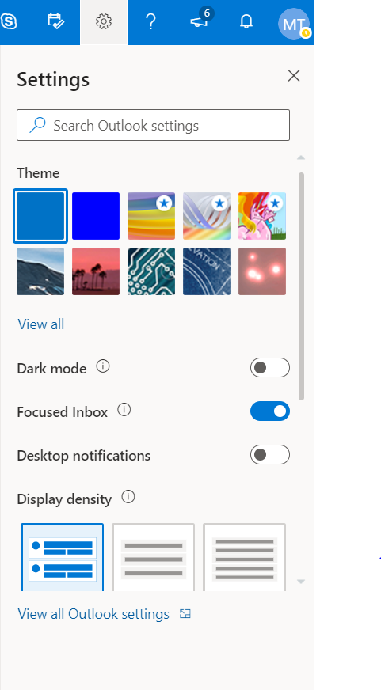
- Then select “Compose and Reply” from the left panel. Then, paste your personalized signature. It should look like the below.
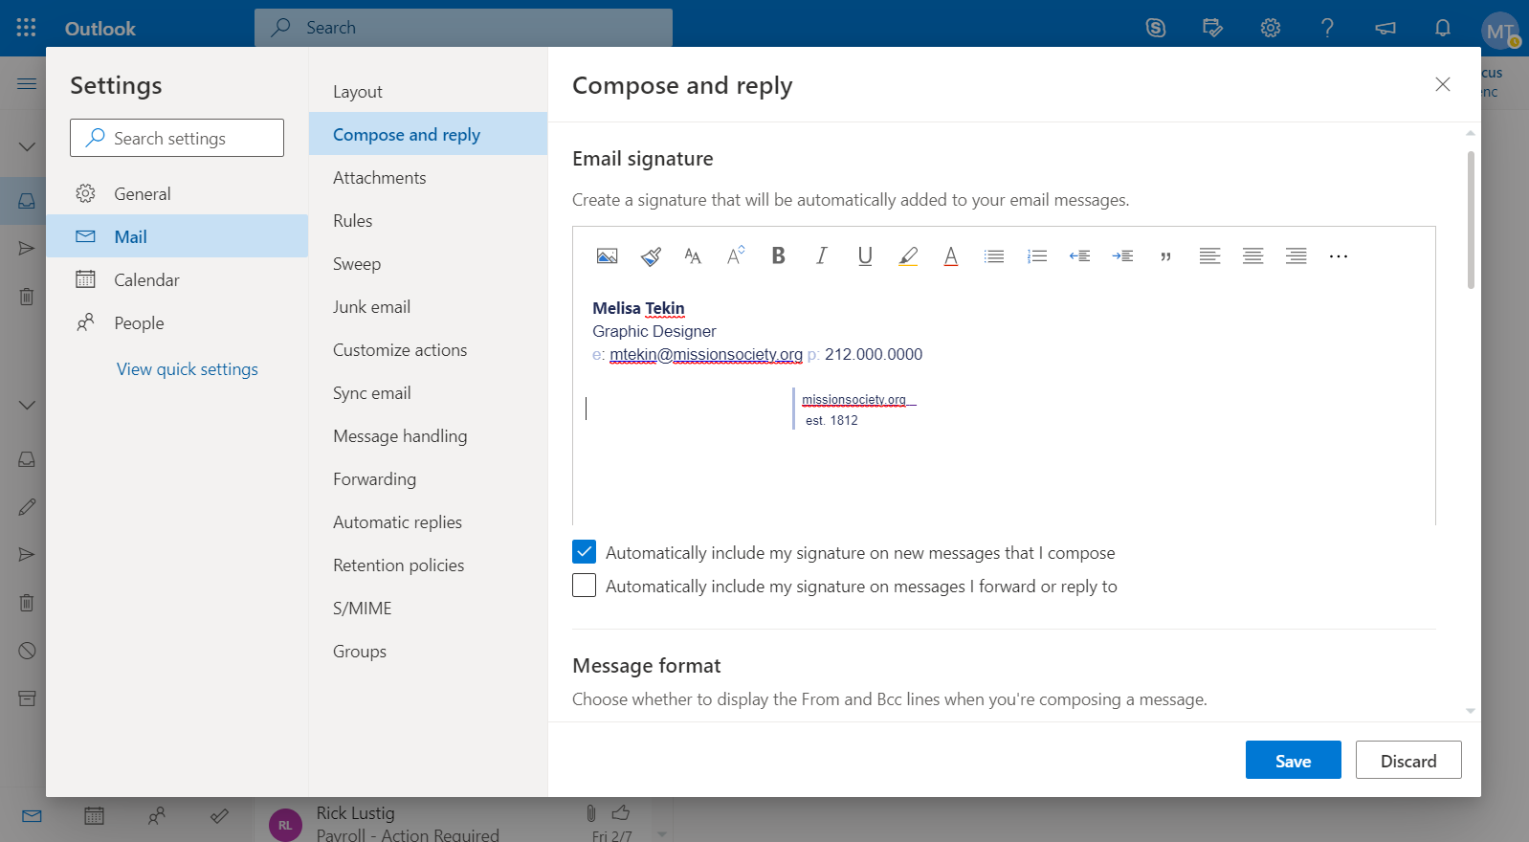

- Open the ‘Mission Society Logo’ Google Doc (found at this link: https://docs.google.com/document/d/1xtnDyUOY9x6lnxCXir2OP2fgKpDYcdAd6jWJry78NfY/edit )

Then, copy the logo, as shown below.

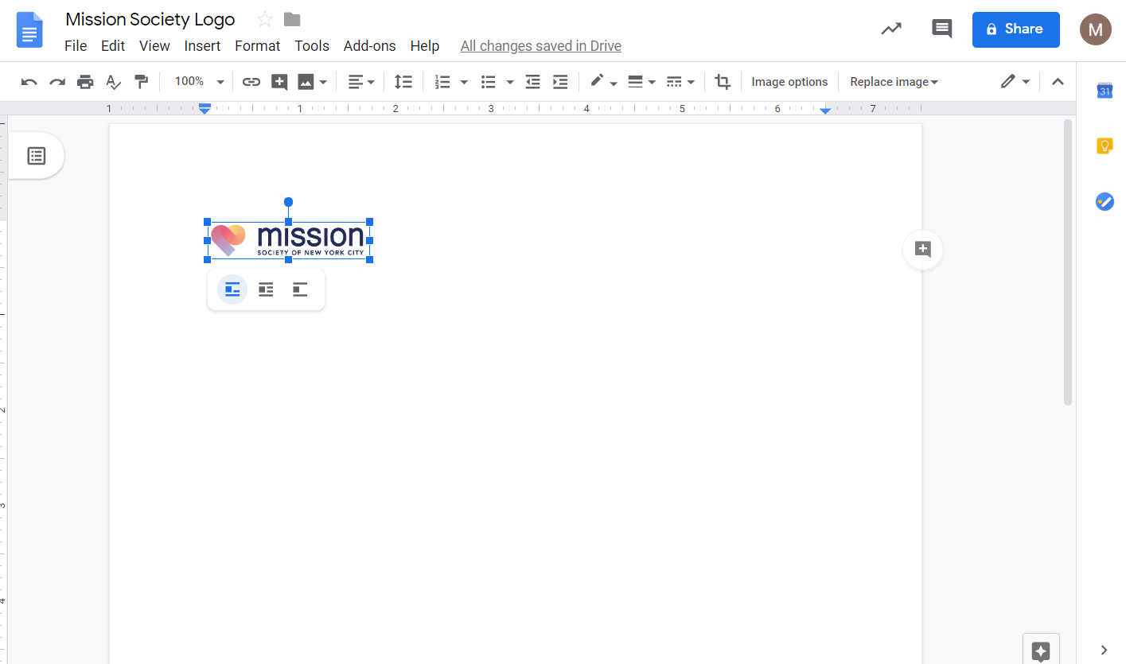

- Go back to the email signature page in Outlook. Hover your mouse and then click where the logo should go (see arrow in red below) and paste the logo.
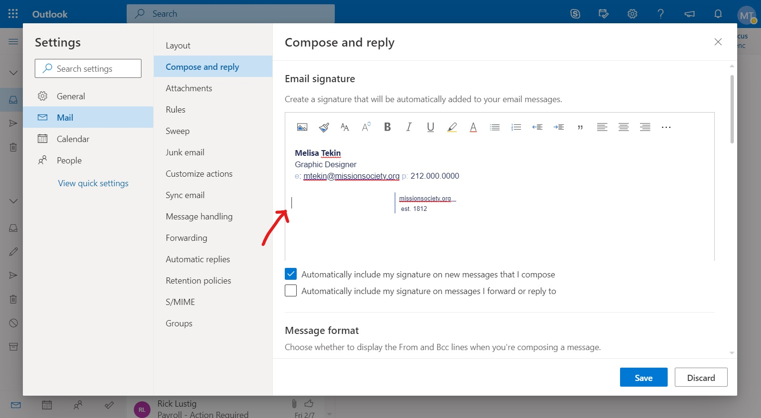

- Your final signature is done! Click ‘Save.’
